# CS 255 System Design Document Template

## UML Diagrams

### UML Use Case Diagram

### 

### UML Activity Diagrams

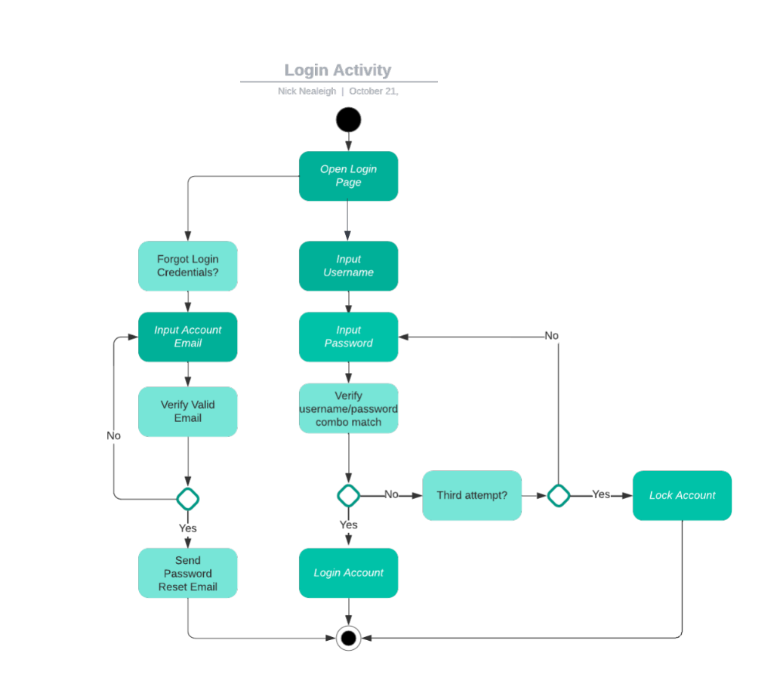

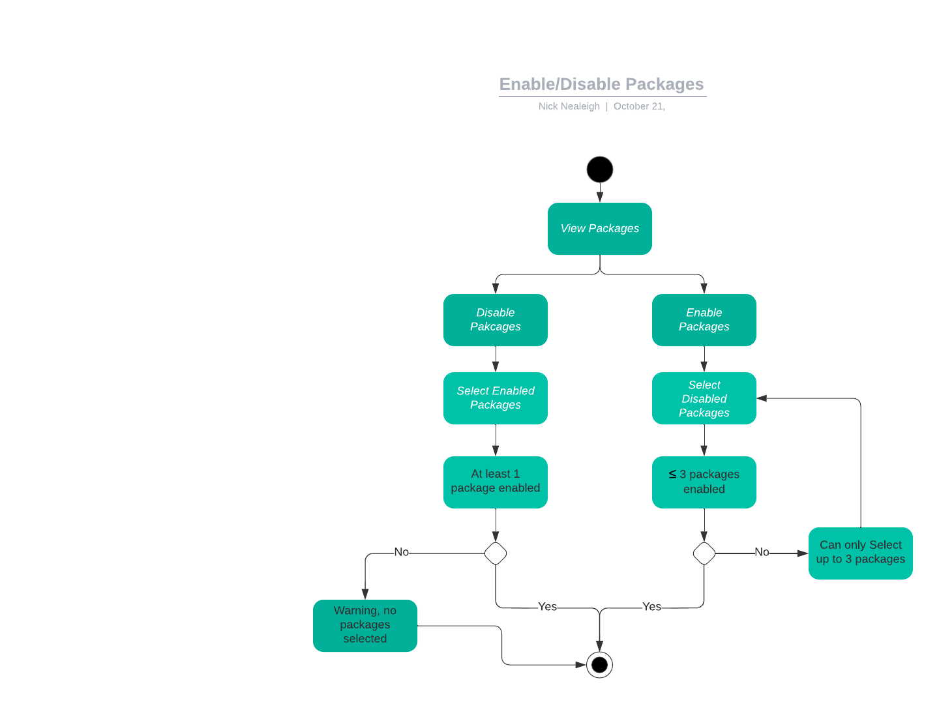

### UML Sequence Diagram

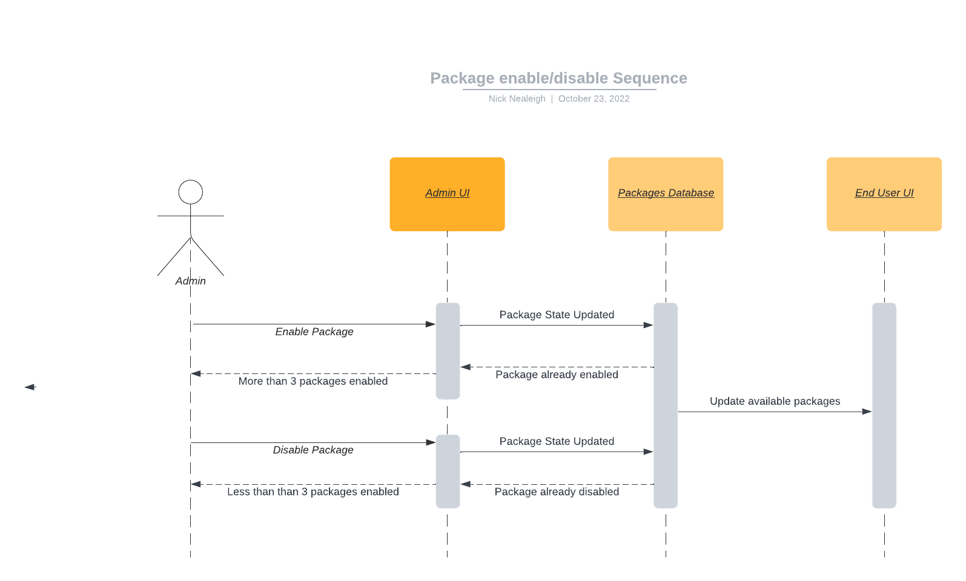

### UML Class Diagram

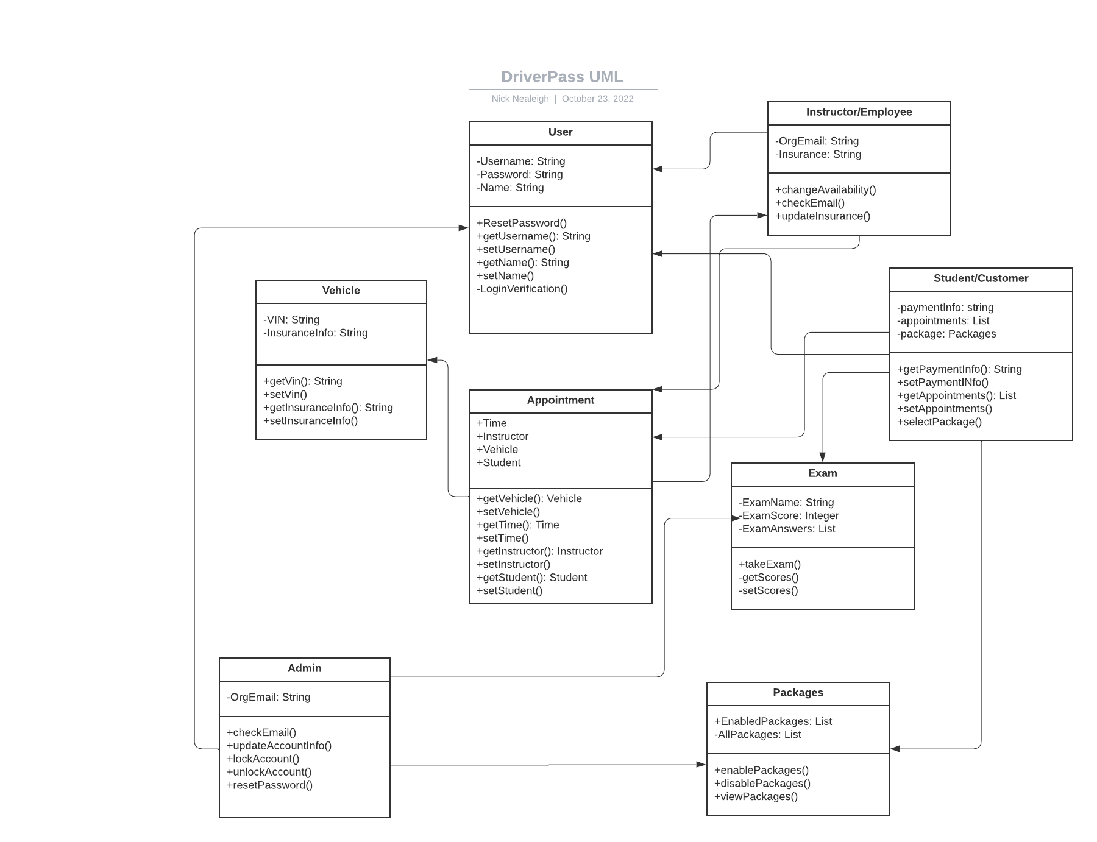

## Technical Requirements

Hardware

* Azure Cloud for hosting and security
* User devices
  + Mobile/Tablet
  + Laptop
  + Desktop

Software

* Supported browser
  + Chrome
  + Safari
  + Firefox
  + Edge
* Azure Cloud Security integration
* OS
  + Linux
  + Windows
  + MacOS

Tools

* IDE
  + Visual Studio
  + Eclipse
* Workstation
  + Laptop
  + Desktop
* LucidChart
  + Process and Object Modeling

Infrastructure

* Stable Internet connection
  + Organization
    - HighSpeed Broadband
  + Customer
    - HighSpeed Broadband
    - Mobile Data
    - WiFi